HEADING: : | Dark Purple 1, Light Gold 2 | 20
TYPES: | Green | 18
SUBTYPES: | Yellow | 16
Important Points: | Orange | 16
Important Points: | Gold | 16
Important Points: | Lime | 16

UNIT 1: Overview of DBMS

Database design

Query processing

Data modelling

ER, EER,

Object Oriented Databases,

Object Relational Databases,

Document oriented Databases

Background of NoSQL

XML document

Structure of XML Data

XML Document Schema

Querying and Transformation

API

Storage of XML Data

XML Applications

-----------------------------------------------------------------------------

ER diagram to Relational Model (7 steps)

EER diagram to Relational Model (8 steps)

Relational Model to ER diagram

DESIGN
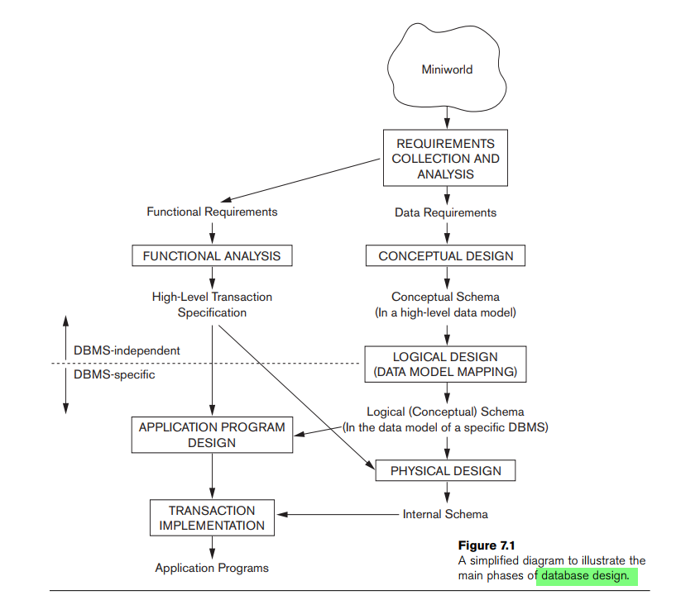

EER to Relational

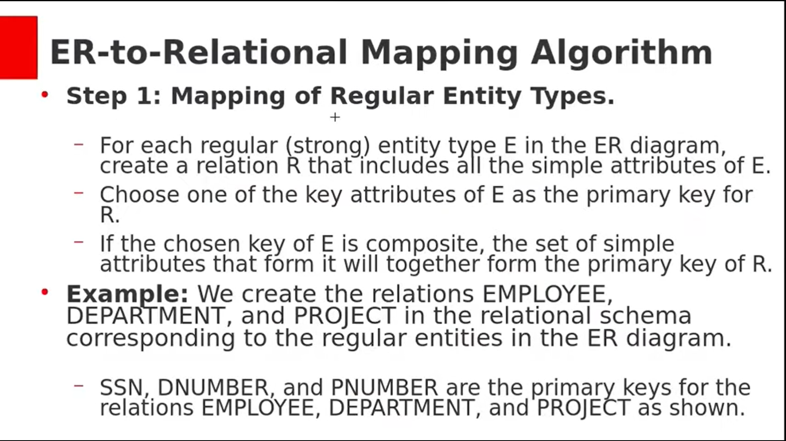

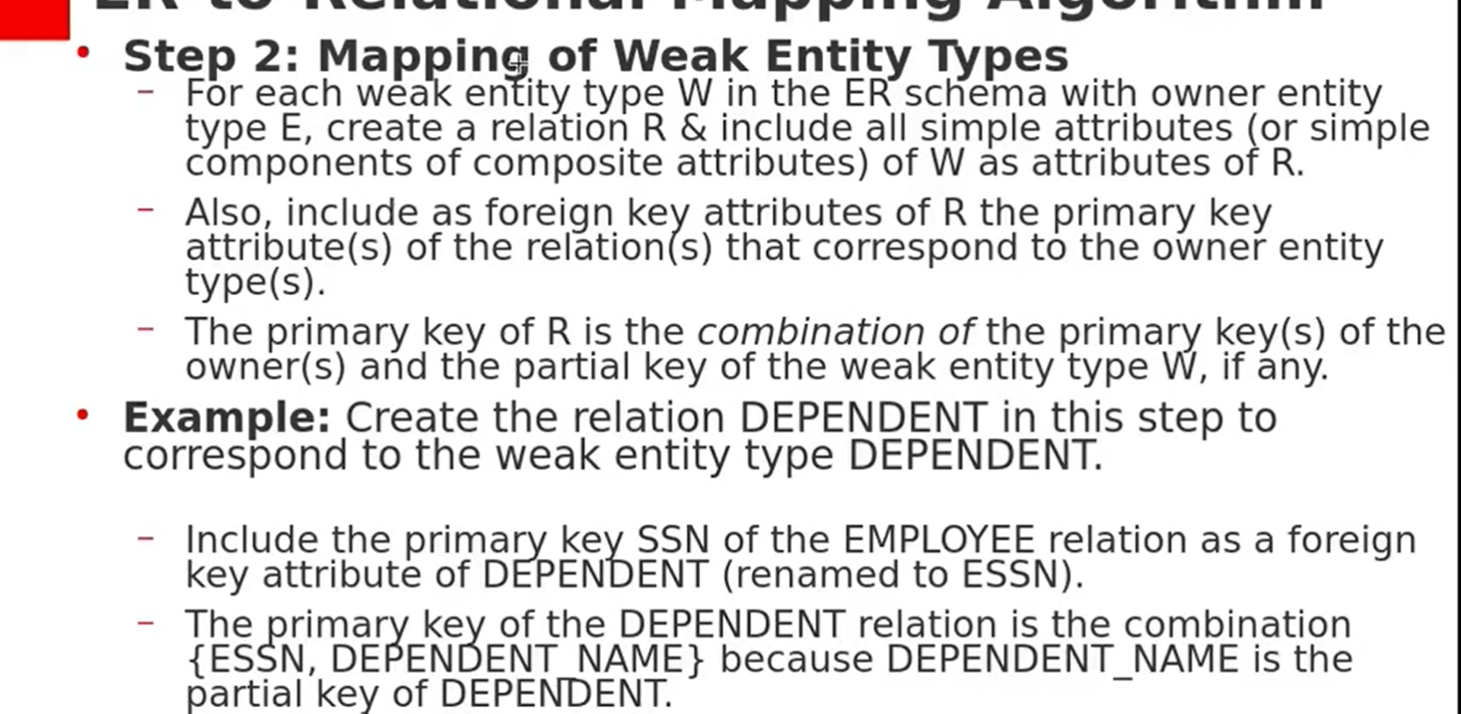

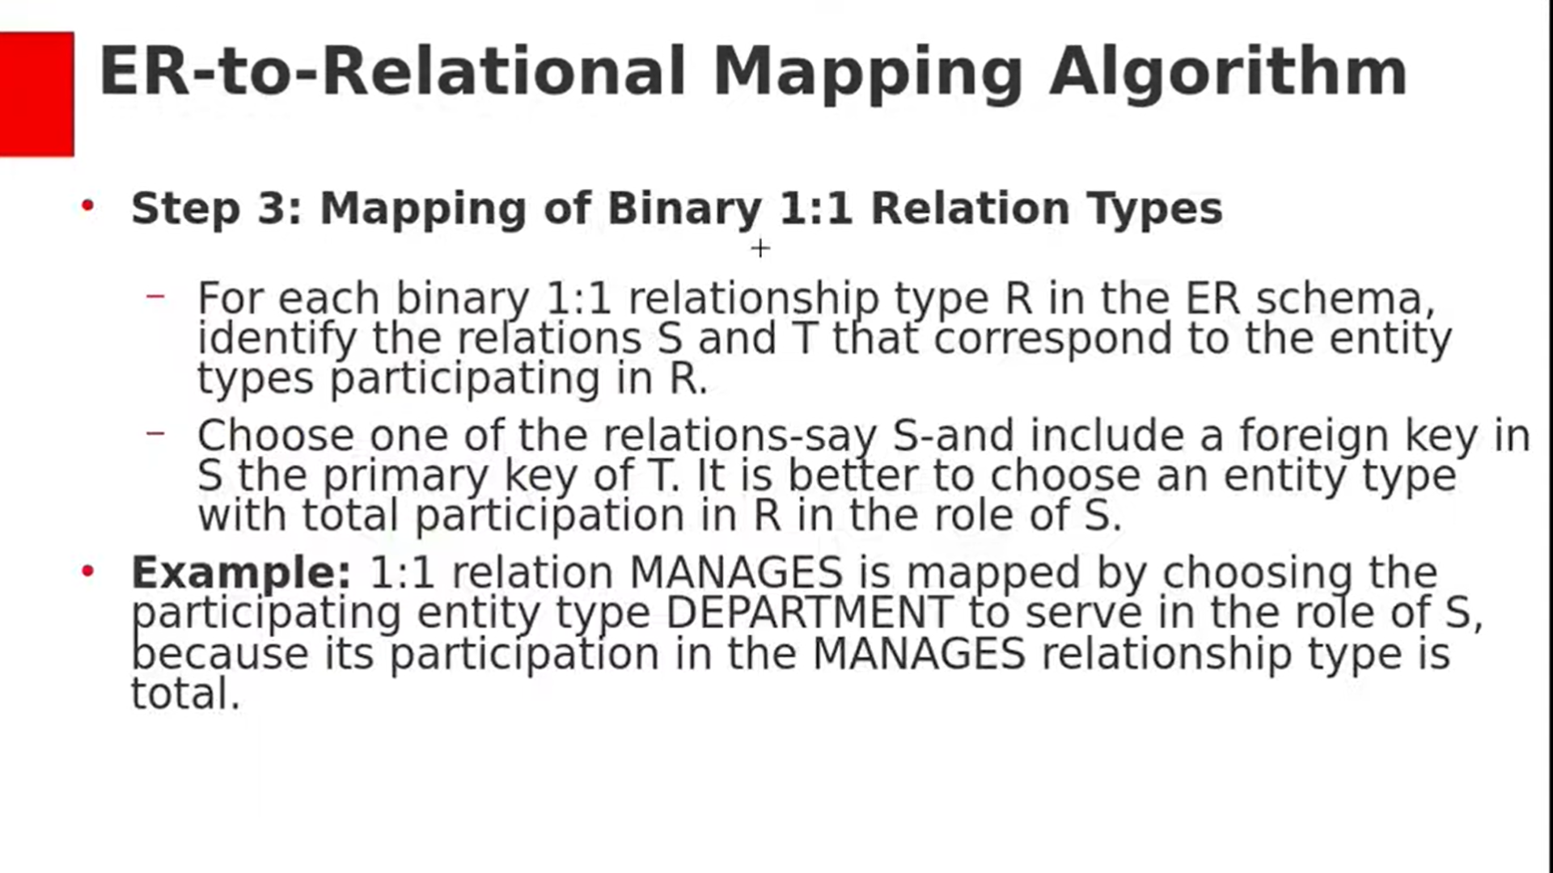

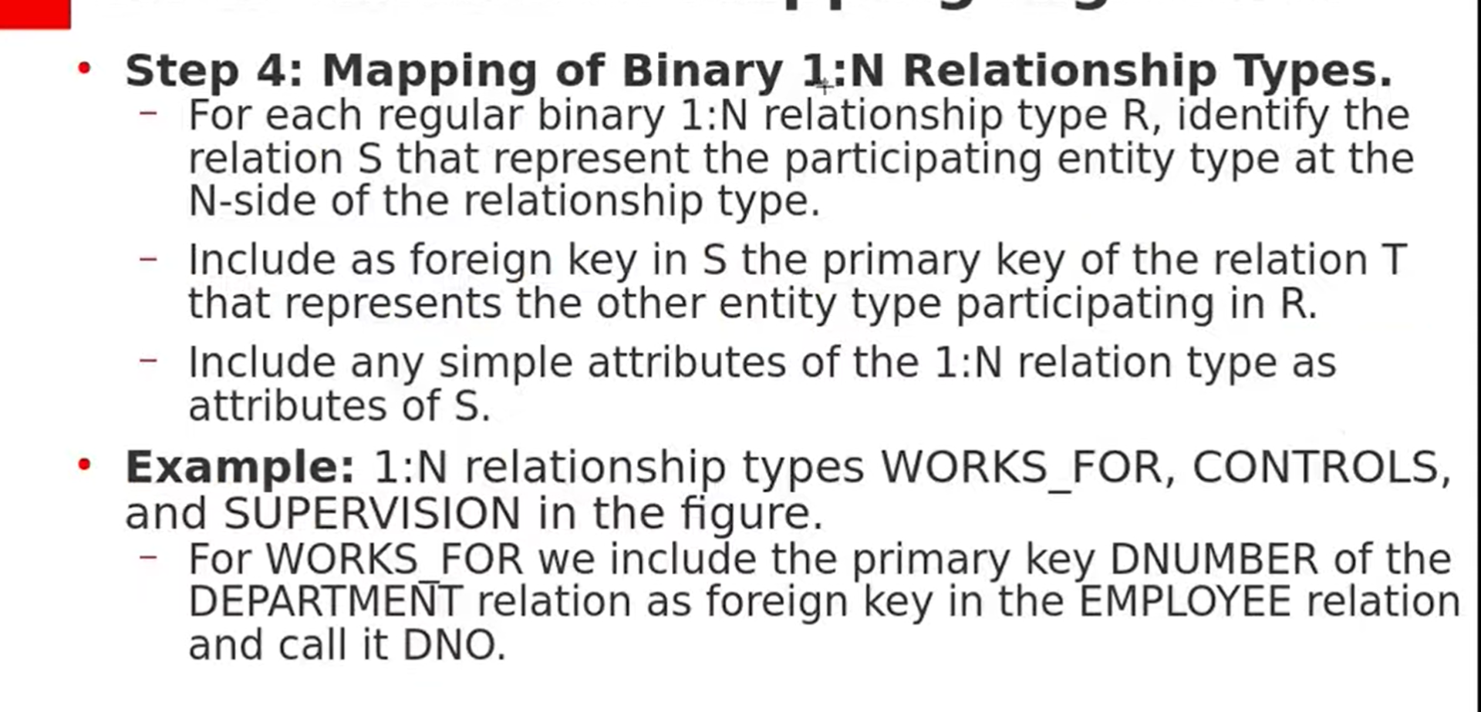

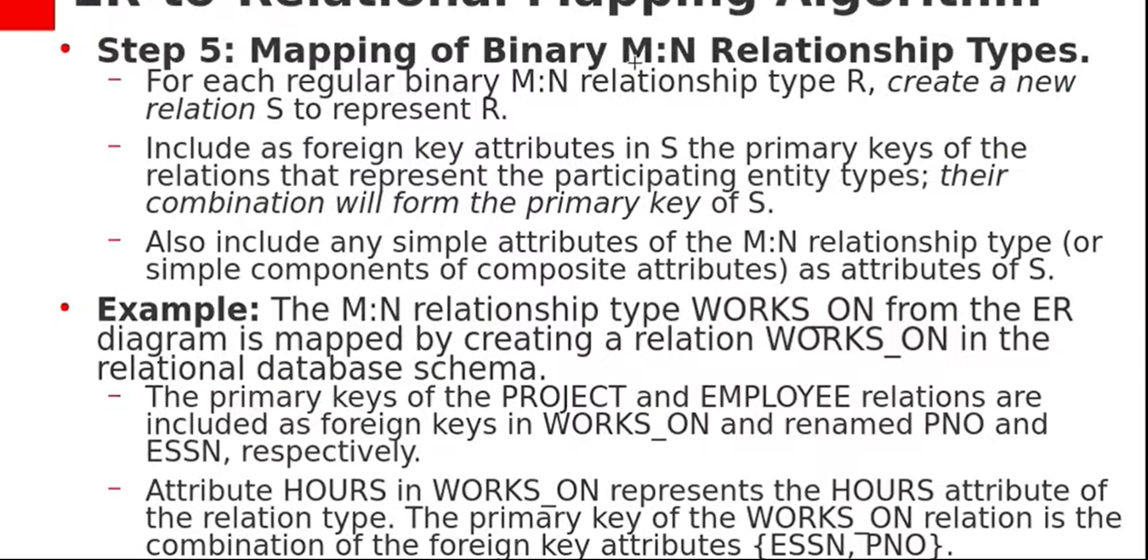

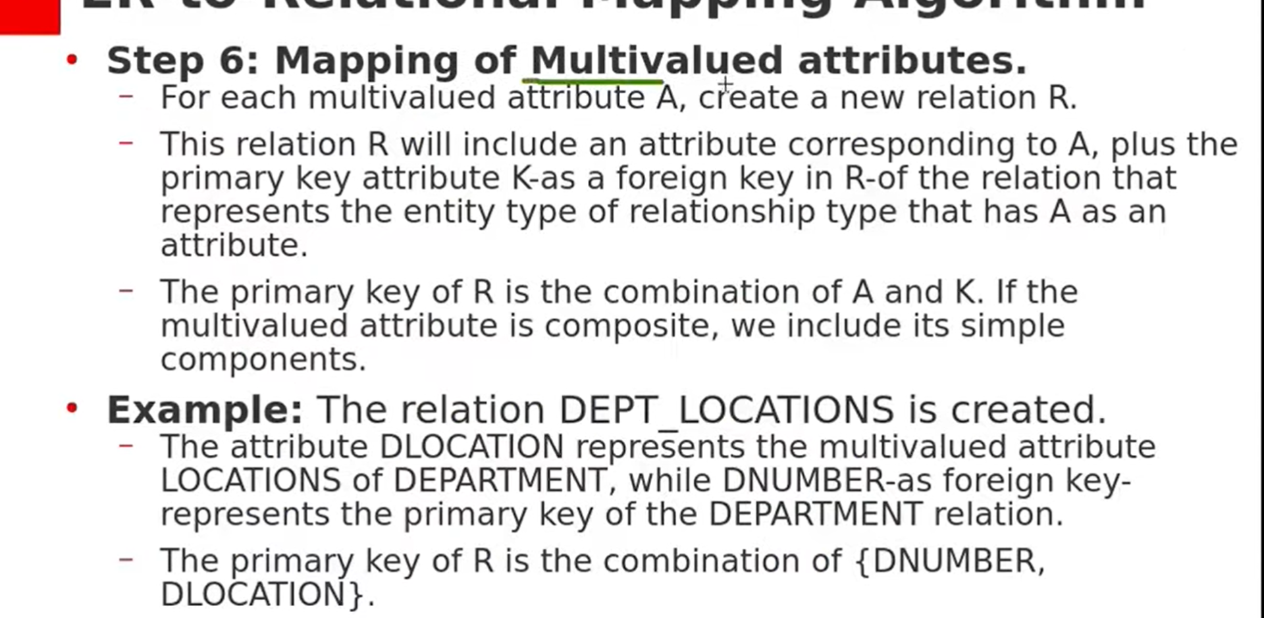
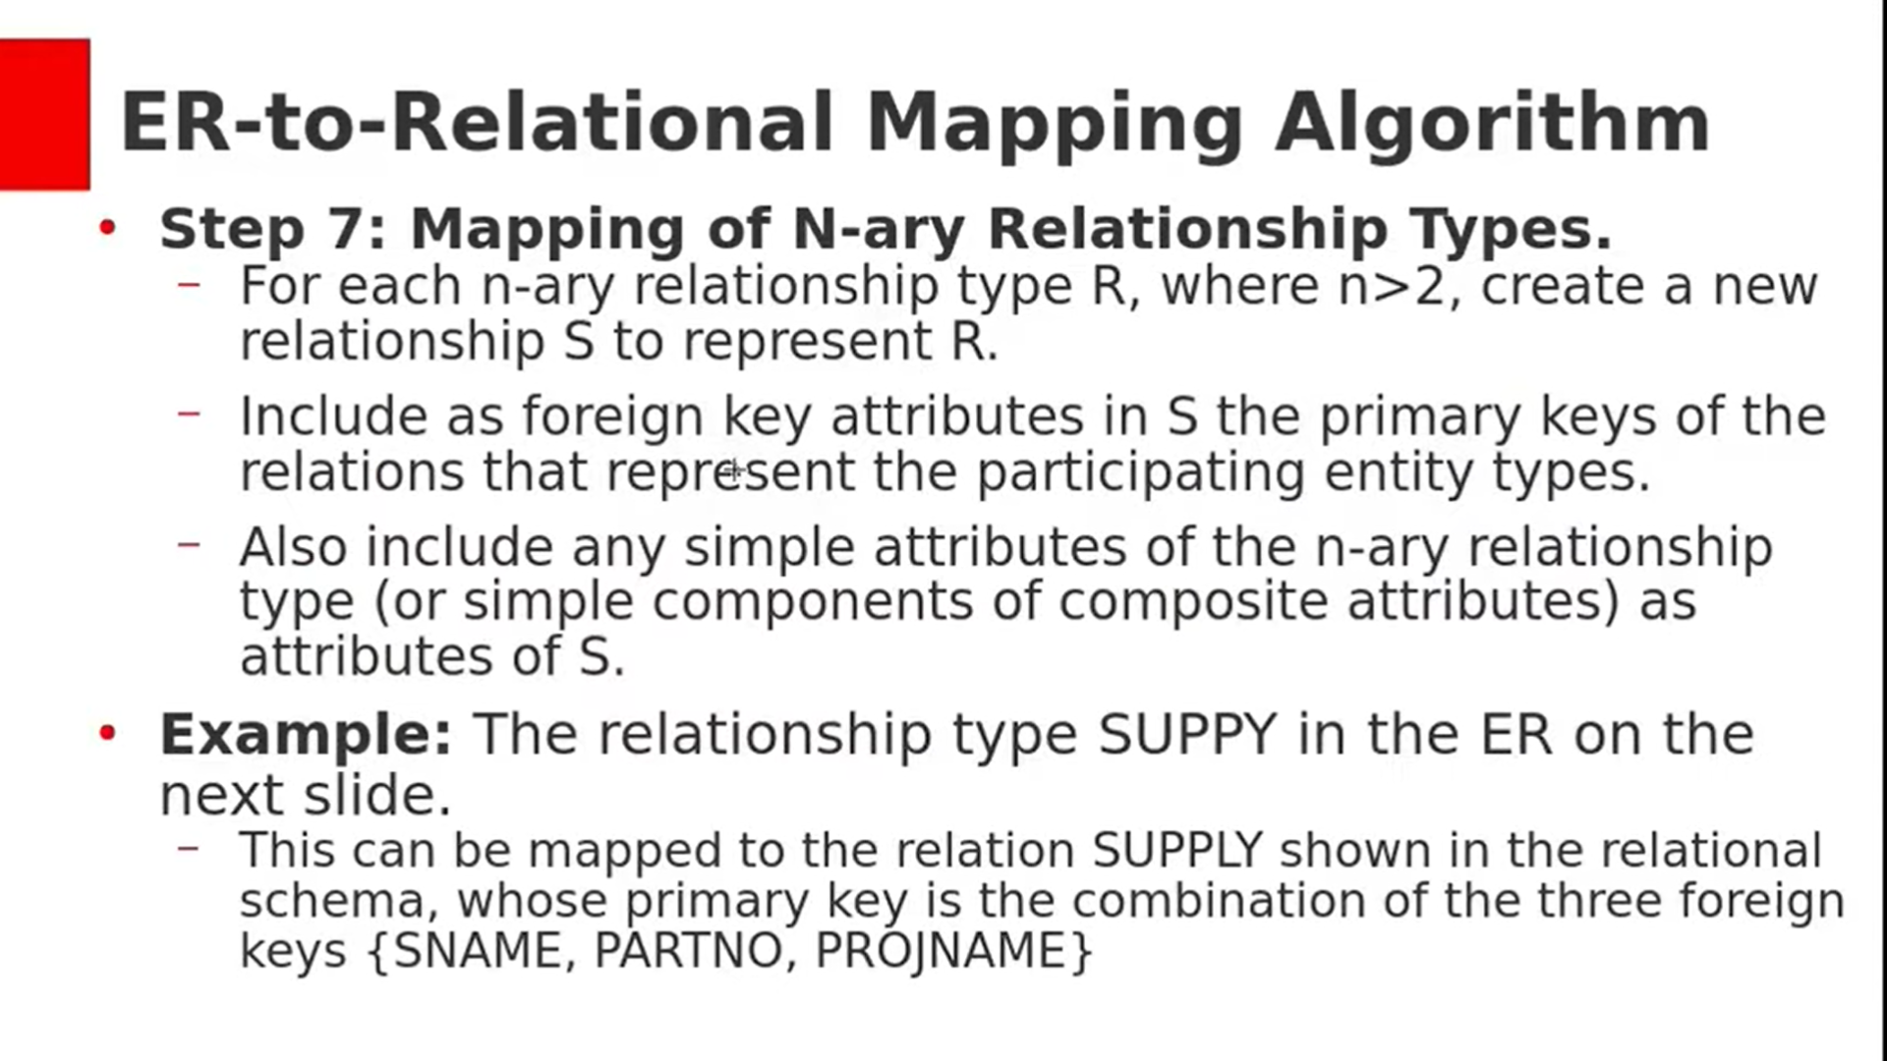

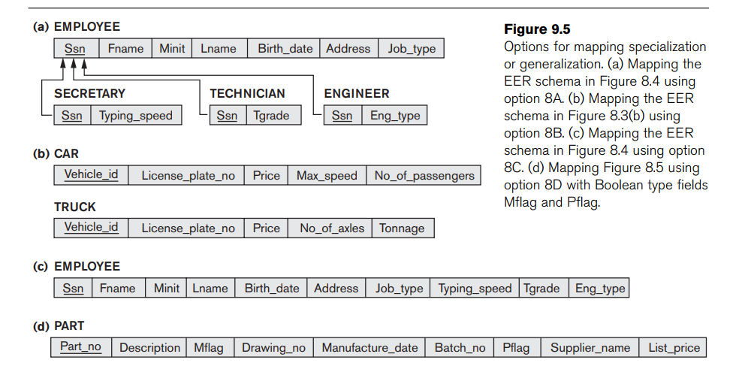

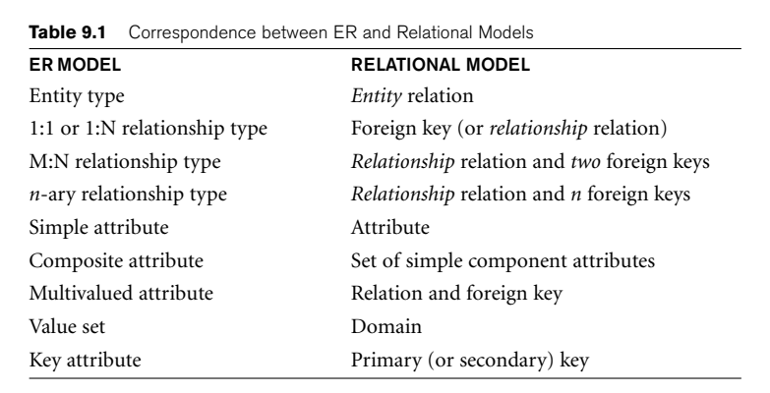

XML

- eXtensible Markup Language

- Markup Language

- Standard for structuring and exchanging data over the Web

- HTML isn’t suitable for specifying structured data extracted from DB

Data

- Structured

- Semi Structured

- Unstructured

XML Document (Element and Attribute)

- Data Centric

- Document Centric

- Hybrid

Well Formed XML

- syntactically correct

- allows to create DOM

Valid XML

- stronger criterion

- well formed, and must follow a particular schema

- element name’s structure is defined in a separate file

- DTD (Document Type Definition) file

- XSD (XML Schema Definition) file

DTD

XSD

XML QUERY:

- XPath

- XQuery

UNIT 2

Overview of OOP;

Complex objects;

Identity, structure etc.

Object model of ODMG,

Object definition Language ODL;

Object Query Language OQL;

Conceptual design of Object database.

Overview of object relational features of SQL;

Object-relational features of Oracle;

Implementation and related issues for extended type systems;

syntax and demo examples,

The nested relational model.

Overview of C++ language binding;

Object Databases (ODB)

ODBMS

Key feature of object databases is that they allow to specify both,

- structure of complex objects

- operations that can be applied to these objects

Objects

An object typically has two components:

- value

- operation

It can have a

- complex data structure

- specific operations defined

Unique Identity to each OBJECT in the database

Implemented via Object Identifier

Maintains integrity bw Real World and Databases

Every OBJECT has OID, Literal Value not have OID (stored in Object)

Type Constructors

Objects can have type structure of arbitrary complexity

Atom

- Built in datatypes

- int, string, bool, float

Struct / Tuple

- Compound or Composite type

- Not a type but a Type Generator

- Name <FName: string, MName: char, LName: string>

Collection

- Multivalued

-

SET: List of distinct elements

BAG: Similar to Set, but elements are not distinct

LIST: Similar to Bag, but elements are ordered

ARRAY: Similar to List, but has a maximum size

Dictionary: Key Value pairs

Declaration of Object types

define type DATE

tuple (Day: Integer, Month: Integer, Year: Integer);

ENCAPSULATION

The concepts of encapsulation is applied to database objects in ODBs by defining the behaviour of a type of object based on the operations that can be externally applied to objects of that type

Operations: Constructor, Destructor, Modifier, Retrieve

The external users of the object are only made aware of the interface of the operations, which defines the name and arguments

The interface part of an operation – signature

The operation implementation – method

The term class is often used to refer to a type definition, along with the definitions of the operations for that type

define class DEPARTMENT

type tuple (Dname: string, Dnum: integer);

operations

no_of_d: integer;

create_d: DEPARTMENT;

add(e: EMPLOYEE): boolean;

INHERITANCE

Inheritance allows the definition of new types based on other predefined types, leading to type hierarchy

A type in its simplest form has a type name and a list of visible (public) functions.

Person is supertype

Employee and Student are subtype

Subtype has all the functions from supertype + functions of their own
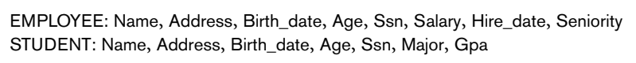

Stored Attribute = Name, Birth_date, Hire_date, SSN

Operations = Age, Seniority, Gpa

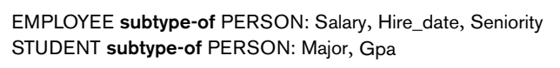

Declaring subtypes doesn’t create the objects.

We have create the objects.

The object, if it belongs to a subtype, should also belong to supertype

Multiple INHERITANCE

Multiple inheritance occurs when a certain subtype T is a subtype of two (or more) types and hence inherits the functions of both supertypes.

This leads to the creation of a type lattice

Subtype ENGINEERING_MANAGER that is a subtype of both MANAGER and ENGINEER.

Problem:

- Subtype can inherit function of same name in both M and E

- SALARY in M as well E

- It may be possible M and E inherit SALARY from Person

- Ask the user to choose from which type SALARY is being inherited

- Use system default type

- Disallow creation of subtype unless SALARY name is changed

Selective INHERITANCE

Selective inheritance occurs when a subtype inherits only some of the functions of a supertype. Other functions are not inherited.

An EXCEPT clause may be used to list the functions in a supertype that are not to be inherited by the subtype

. .

Overview of ODMG Model

Page 406

EER to ODB Schmea

Page 426

Overview of the C++ Language Binding in the ODMG Standard

Page 436

UNIT 3

INFORMATION INTEGRATION

Definition:

The process of merging multiple databases (or information sources) to function as a single database.

- Physically (Warehouses)

- Virtually (Mediators or Middleware)

Challenges:

To resolve the conflicts, “Wrappers” are designed as translators between source data and integrated database schema

Query Optimization: ID require QO. Mediator systems,

Global-as-View:

ID data is defined by how its constructed from the S

Local-as-View:

SD is defined by the schema supported by ID

Why Information Integration?

- Ideal Scenario: Data could be put into a SINGLE db from scratch

- But many Databases are created independently

- Creating a new single database from scratch is costly

Middleware (layer of abstraction on top of existing db)

- Legacy system continues serving current applications

- New applications can access middleware for data

Heterogeneity Problem

When integrating independently developed information sources, problems arise!

Heterogeneous Sources and Heterogeneity Problems

Toyota Automobile has 1000 dealers.

Each dealer maintains separate database.

Toyota want to create integrated database.

1) Communication Heterogeneity

- Some dealers use HTTP (making db available on Web)

- Some dealers use FTP

2) Query Language Heterogeneity

How we Query or Modify the database

- SQL or not (Different versions of XML)

- Non relational, Object Oriented, Excel, XML db

3) Schema Heterogeneity

Variances in Schema

Cars (SerialNo, Model, Color, Available)

Auto (UniqueN, Model, Available) Options (UniqueN, Gears)

- Missing Values: Color

- Number of Relations: 1 and 2

- Atrribute Names difference: SerialNo, UniqueN

4) Data Type Differences (SerialNo)

- Strings (or) Integers

- Length of Strings might differ

5) Value Heterogeneity

Different representation of the same concept

Eg: Color: {STRING Black, INTEGER 20, CODE BL}

6) Semantics Heterogeneity

Differing interpretations of terms

- Trucks classified as Cars

- Trucks not classified as Cars

Modes of Integration (3)

FEDERATED Databases

- Sources are independent

- But one source can supply information to another source

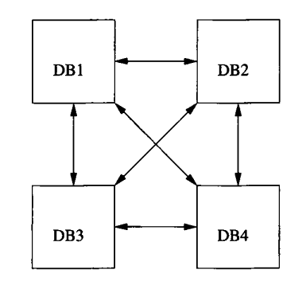

- One to One connections between all pairs

- Requires n(n-1) components to be coded

Data Warehouses

Data from several sources is extracted and combined into a global schema

Data is then stored at Warehouse, which looks like an ordinary database to the user

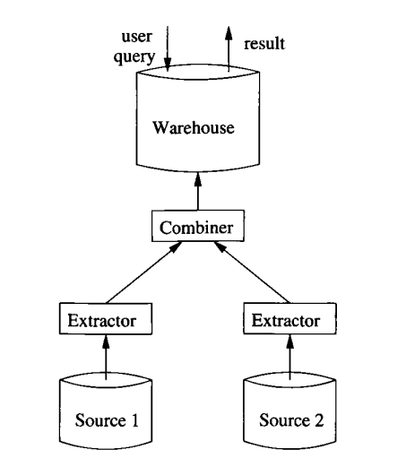

Two approaches to construct the data in the warehouse:

1)

- The warehouse is periodically closed to queries

- Reconstructed from the current data in the sources

- Reconstruction occurs once a night (or) at even longer intervals

- Most common approach

2)

- The warehouse is updated periodically (eg, each night)

- Based on the changes made to the sources

- Involves updation of smaller amounts of data

- Important if the warehouse is large needs quick modification

- Calculating changes required to the warehouse is complex

Mediators

A mediator is a software component that supports a virtual database, which the user may query as if it were materialized (as a warehouse)

- User issues a query to the mediator

- Mediator has no data of its own, it gets the data from its sources

- Mediator sends query to its Wrappers, which queries the sources

- Mediator combines the result and synthesizes the response

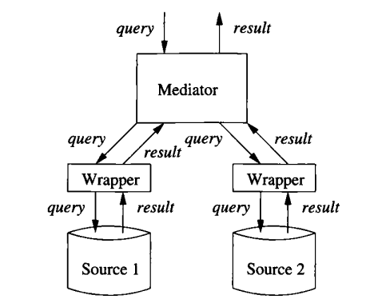

Models of Parallelism

Shared MEMORY
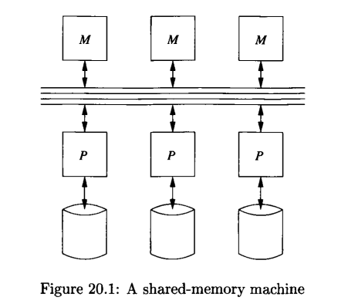

- Each Processor has access to all Memory of all processors

- NUMA

Shared DISK
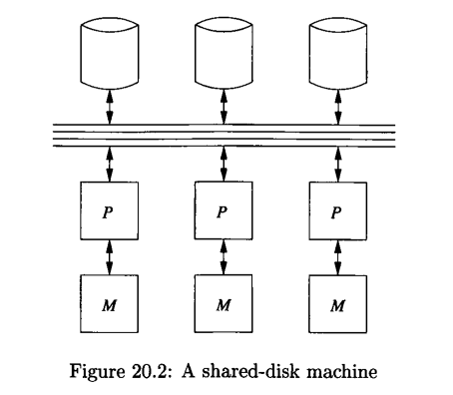

- Memory is not accessible. But Processor can access Disk via CN

- NAS, SAN

Shared NOTHING
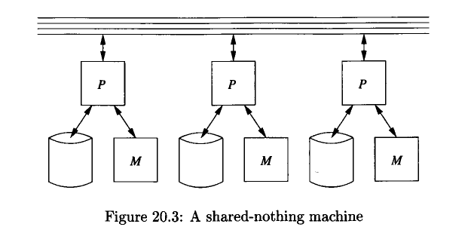

- All Processors have their own Memory and Disk

- Used for Database Systems

MAP REDUCE
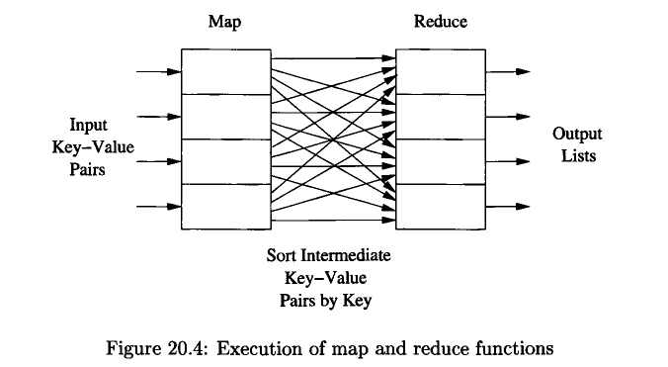

DD

UNIT 4

DD

UNIT 5

MOBILE DATABASE

Recent advances in portable and wireless technology led to mobile computing, a new dimension in data communication and processing.

Mobile coupled with wireless communications allow clients to access data from virtually anywhere and at any time.

Challenges

■ The limited and intermittent connectivity afforded by w/l comm

■ The limited life of the power supply (battery)

■ The changing topology of the network.

■ New architectural possibilities and challenges.

Characteristics

- Intermittent Connectivity

- Limited Battery

- Changing Client Location

- Communication Latency

Mobile Computing Architecture
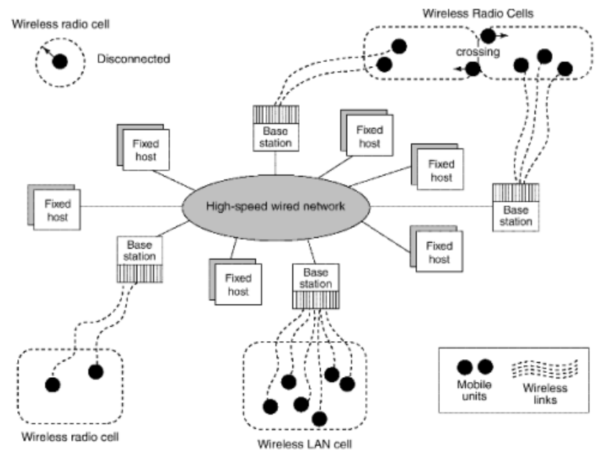

- Distributed Network

- Fixed Hosts and Base Stations are interconnected through HSWN

- FH: Configured to manage Mobile Units

- BS: Gateway to fixed network for Mobile Units

- Wireless Communications:

Bandwidth lower than wired. 2G, 3G, LTE

Range. Locality of Access. Interferences

- Client Network Relation:

Mobile can move around the geographic mobility domain.

Domain -> Cells. Each cell has a Base Station

Traditional Client Server

OTHER (Infrastructure LESS):

- MANET

- Mobile Ad Hoc Network

- Self Configuring mobiles that connect to other mobiles

- Bluetooth

- P2P

MULTIMEDIA DATA

TEXT

- Formatted, Unformatted

- For Parsing, structured documents (HTML)

GRAPHICS

- Drawings, Illustrations

- Encoded with Descriptive Standards

- CGM, PICT, Postscript

IMAGES

- Photographs, Pixel Data

- Bitmap, JPG, JPEG, PNG

ANIMATIONS
- Temporal sequence of images

- GIF

VIDEO

- Sequenced photographed data at specific rates

- 30 frames per second

- MP4, MKV, MOV

AUDIO

- Aural recordings

- Analog recording -> Digital format

COMPOSITE Data

- Mixed Multimedia

- Audio + Video

GEOGRAPHIC INFORMATION SYSTEMS

They are used to collect, model, analyze information describing physical properties of the geographical world.

Spatial Data

Maps, Political Boundaries, Roads, Rivers, Elevation

Non Spatial Data

Census counts, Sales and Marketing information, Economic data

Applications or Categories

It is possible to divide GIS into three categories:

■ Cartographic applications

■ Digital terrain modeling applications

■ Geographic objects applications

- online map services

- vehicle-navigation systems (GPS)

- land usage information for ecologists and planners.

- distribution-network information for public-service utilities such as telephone, electric-power, and water-supply systems

Vector Data

Geometric objects such as Point, Line, Polygon

- Map data

- Road – Poly Lines

- Countries – Complex Polygons

Raster Data

Array of points, where each point represents value of a real world

- Bitmaps or Pixel maps (2 or more dimension)

- Satellite image

- + actual image, contains metadata (loc, lat, long)

- Represented by TILES, each covering certain area

TIN (Triangulated Irregular Network)

DTM (Digital Terrain Modelling)

(Page 1097: DC)

GENOME Database

Biology encompasses: Environment, Ecology, Anatomy, Histology

GENETICS: Genes are unit of heredity

- Mendelian

- Molecular

- Population

DNA (DeoxyriboNucleic Acid) – 1867

Watson and Crick – Double helix structure – 1953

GENOME

Total genetic information that can be obtained about an entity

Human Genome: Complete set of genes to create humans

30000 genes spread over 23 pairs of chromosomes, 3billn nucleotides

HGP:

- Obtain the ordering of the bases

GenBank

- DNA Sequence Database

- National Center for Biotechnology Information (NCBI)

- 1978

- 100 GB uncompressed

- 31 billion nucleotide bases

- 1400 organisms

- ASN.1

Genome Database (GDB)

- 1989

- Human gene mapping data

Online Mendelian Inheritance in Man

- genetic basis of human disease.

EcoCyc

- E coli K 12



